**SY486: Thumbnail Cache Viewing: In class**

You will create an image and delete it. Then you will recover evidence of it from the Thumbnail Cache. This sort of evidence is often used in child pornography cases, to show that someone viewed a forbidden image.

**Creating an Image**

Open Paint. Click the brush icon, and select an color and type in two words or so.

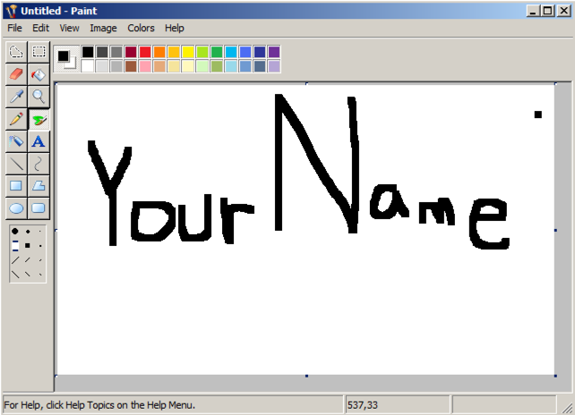

Write your name using the mouse, as shown below. Don't use the literal text "Your Name"--use your own name.

Save the file in your Pictures folder with the name "YOURNAME". Don't use the literal text "Your Name"--use your own name. Accept the default File Type of JPG.

1. Close Paint.
2. In the Windows 10 –search (type Pictures) to search for the pictures folder.
3. **You should see your .jpg**
4. Close the Pictures folder

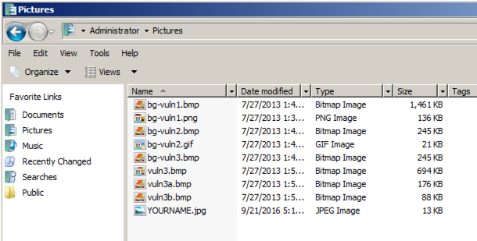

1. Search for File Explorer Options 🡪View at the top
2. 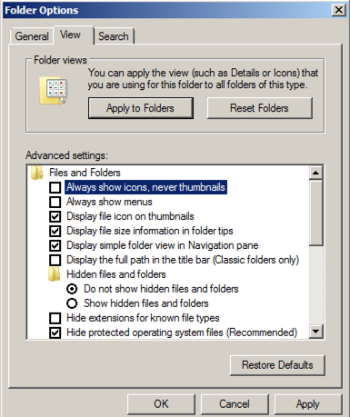Clear the "**Always show icons, never thumbnails**", box, as shown below. Click **OK**.

7. Go back to the Pictures folder. Click the file with your name on it. You should see a thumbnail version of it at the lower left, as shown below.

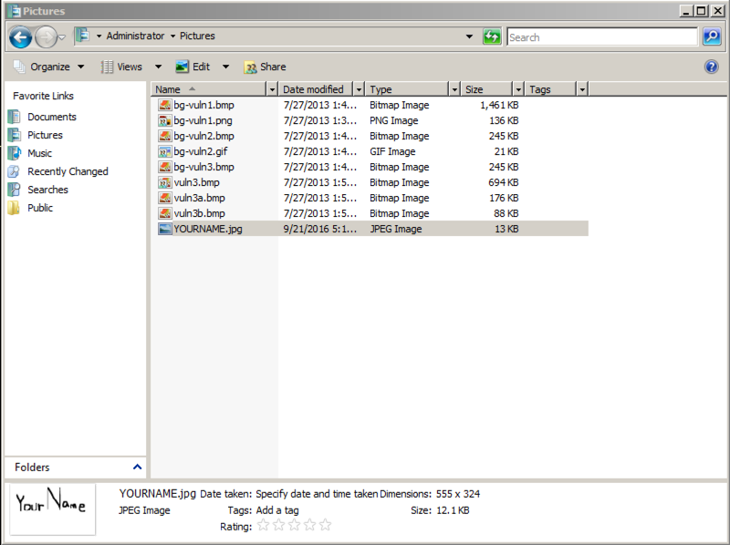

8. Drag the "YOURNAME " file into the Recycle Bin

9. Right-click the Recycle Bin and click "**Empty recycle bin**". Click **Yes** to confirm the deletion.

**Thumb cache Files**

1. Search again for File Explorer Options 🡪View at the top
2. Make these two adjustments, as shown below:
   1. Click the "**Show hidden files, folders, or drives**" button
   2. Clear the "**Hide protected operating system files (Recommended)**" box. In the Warning box, click **Yes**.
3. Click Ok.

**Thumbcache Viewer**

1. Download thumbcache viewer from here: https://thumbcacheviewer.github.io/
2. On the left side, click the "Download Thumbcache Viewer" button.
3. Download the thumbcache_viewer.zip file. Unzip it. Run the thumbcache_viewer.exe file.
4. In "Thumbcache Viewer", click File, Open.
5. Navigate to C:\Users\Administrator\AppData\Local\Microsoft\Windows\Explorer and double-click thumbcache_256.db.Please check the latest created 256 database.
6. A list of files with long hexadecimal names appears, as shown below:

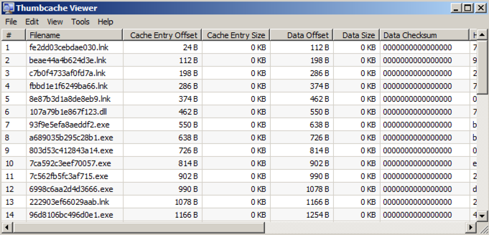

1. Many of the images have "Data Size" of zero. Click the gray **Data Size** column header to sort the list by size.
2. Click the largest image.
3. The image appears in Image Viewer, as shown below

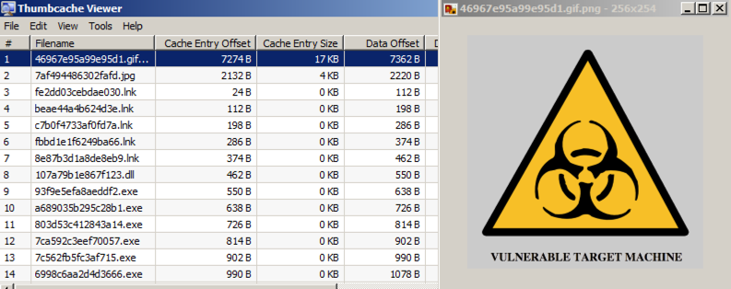 Press the down-arrow key to scroll through the images and find one with your name on it, as shown below